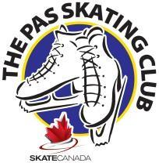
THE PAS SKATING CLUB
2023 - 2024
StarSkate Program

The STARSkate Program is a recreational figure skating program. This program offers opportunities for skaters of all ages to develop fundamental figure skating skills in the areas of ice dance, skating skills, free skate and interpretive skating. Skaters will learn in a group and/or private lesson format. Skaters have the opportunity to compete at STARSkate Competitions and take Skate Canada Tests through a nationally standardized testing system. STARSkaters may become Program Assistants who help the Coach during the CanSkate skating lessons. At the end of the skating season, skaters participate in an ice review that allows them to showcase their skating development in a fun and positive way.

Location: RHJ Arena Start Date: Sept. 19, 2023
Schedule: *Tuesdays 4:15 pm – 5:30 pm End Date: *April 18, 2024
*Thursdays 4:15 pm – 5:30 pm Year-End Review: *April 14, 2024
Saturdays 8:30 am – 10:30 am
*Dates and times subject to change

Test Days: To Be Determined – will be communicated through coach and email.

This schedule is subject to change. Please check The Pas Skating Club bulletin board at the rink, or the Club website for schedule changes: www.skatethepas.uplifterinc.com

Professional Skate Canada Coach: Sherry Hunter

Program Cost: $639.65 + $58.70 Skate Canada Insurance + $200 Refundable Fundraise Fee = $898.35

